**Press release** October 2019*Specialist press*

**Thomas Hartkämper is new COO of Kautex Maschinenbau**

**As of October 1, Thomas Hartkämper is responsible for operations at Kautex Maschinenbau. The experienced change management and organization development expert is set to play a significant role in structuring the company’s change process. Kautex is one of the world’s leading manufacturers of extrusion blow molding machines for plastics processing.**

For many years now, Mr. Hartkämper has held managerial positions in mechanical and plant engineering companies that operate on the global stage. The 50-year-old champions sustainable business dealings, ensuring that they are aligned consistently with customer requirements. He knows the plastics industry inside out thanks to his many years of experience, particularly in manufacturing machines and tools for plastic packaging.

Dr. Olaf Weiland (CEO and Partner) is delighted with the new addition to the company. “Here at Kautex Maschinenbau, we are going through a process of radical change which will affect all divisions of our company. The keywords are packaging focus, the circular economy, and digitalization. Thomas Hartkämper is an excellent team player. He can contribute the necessary expertise and long-standing experience to manage and structure our change process successfully – particularly in operations. Being lucky enough to now count him among our team is a very good move for Kautex Maschinenbau and a great pleasure for me personally.”

Hartkämper himself believes that the company is on the right track: “With the slogan for this year’s plastics trade show being CREATING CHANGE TOGETHER, Kautex is already alluding to forthcoming challenges. I am looking forward to helping this fantastic company become a self-learning organization that generates sustainable added value for its customers.”

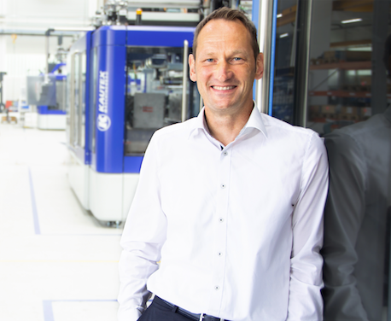  
Thomas Hartkämper  
  
**About Kautex Maschinenbau**Eight decades of providing its customers with innovative products and services have turnedKautex Maschinenbau into one of the world's leading companies in extrusion blow molding technology. With customers that include major automobile manufacturers and suppliers, as well as companies working in the packaging industry. All of them have come to rely on the knowledge and experience of a brand that stands for both quality and reliability. In addition to its HQ in Bonn, a Customer Service Center in Berlin and regional offices in the USA, Russia, China, Italy, India, Mexico and Malaysia, Kautex Maschinenbau operates an extensive global network of service and distribution offices. **Contact details**

**Christian Kirchbaumer**  
Head of Marketing Communications

**Kautex Maschinenbau GmbH**  
Kautexstr. 54  
53229 Bonn  
Germany

T +49 228 489370

christian.kirchbaumer@kautex-group.com